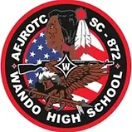
Wando AFJROTC
Doing Great Things
1 July 2022

We hope you have had a great first half of your summer!
Congratulations to all the cadets who completed CLC! We hope you remember and value the lessons, skills, and friendships that were made. Remember to bring all those skills, lessons, and excitement so we can continue to make this unit the best unit possible!
Prep school is coming up quickly! We need all commanders at school July 25 through July 27 (times TBD) for training. If you can not make it, please let us know ASAP!!
Seniors, you will have flight commander training in July as well. It will be July 18-22 (times TBD). You are required to be there. If this week does not work please let us know ASAP!
I have attached a calendar of events on the second page as well as a list of new positions for the upcoming school year on the third page! Please make sure you are on your correct class remind. I have attached the remind codes below. We post frequent updates on the Facebook page, Remind, and website. If you need anything over the summer please contact Group Staff or the instructors, and we will get back to you as soon as possible.
Emails:
john_farese@charleston.k12.sc.us
christopher_owen@charleston.k12.sc.us
wandosc872group@gmail.com
Remind Codes:
Seniors: sc8722023
Juniors: sc8722024
Sopohmores: sc8722025
Freshmen: sc8722026
Parents: sc872par
Facebook: Wando High School AFJROTC SC-872 Unit Official Group
Website: wandoafjrotc.com

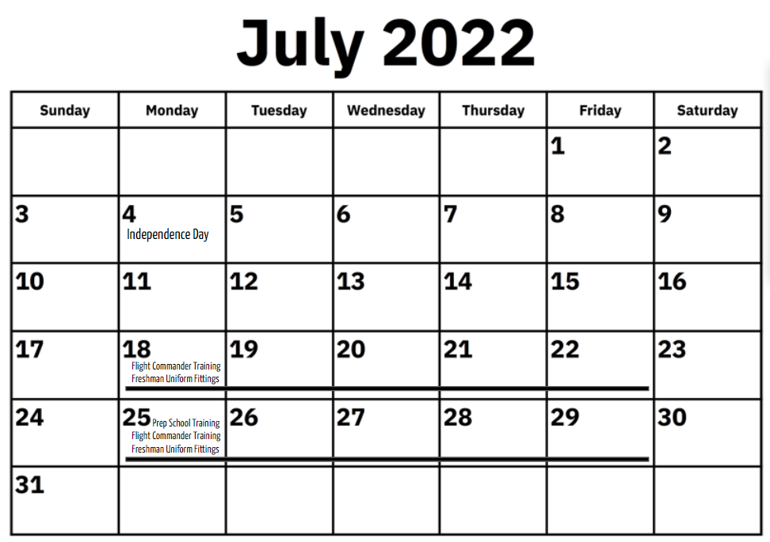

Team Squadron Commander: C/ Maj. Brodene
Team Squadron Assistant Commander: C/ Capt. G. Smith
Aero Team Commander: C/ MSgt. Wright
Cyber Team Commander: C/ First Lieutenant Mart
Drill Guard Team Commander: C/ MSgt. Stone
Drill Guard Assistant Commander: C/ TSgt. Neal
Honor Guard Team Commander: C/ First Lieutenant Visser
Honor Guard Assistant Commandant: C/ Second Lieutenant Simmons
Marksmanship Team Commander: C/ MSgt. Morales
Marksmanship Assistant Commander: C/ TSgt. Fenton
Raider Team Commander: C/ MSgt. Jurand
Raider Assistant Commander: TBD

Public Affairs Squadron Commander: C/ Maj. Doll
Public Affairs Assistant Commander: C/ MSgt. Richardson
Planning Commander: C/ MSgt. M. Smith
Historian Commander: C/ First Lieutenant Sullivan
Awareness Presentation Commander: C/ MSgt. Humphrey

Mission Support Squadron Commander: C/ Maj. Green
Mission Support Assistant Commander: C/ Capt. Watson
Athletics Commander: C/ MSgt. Carretta
KittyHawk Commander: C/ MSgt. Henry-Wragg
Morale Commander: C/ MSgt. Gill
Recruiting Commander: C/ MSgt. Wright
Finance Commander: C/ First Lieutenant Davidson
Finance Assistant Commander: C/ TSgt. Thomson

Logistics Readiness Squadron Commander: C/ Maj. Alford
Supply Commander: C/ First Lieutenant King
Admin Commander: C/ MSgt. Neal

Chief Stan-Eval: C/ Maj. Z. Johnson
Stan-Eval Commander: C/ Capt. Gunnar Lee
Stan-Eval Commander: C/ Capt. Kloiber

